Elementary school Vladimir Nazor Budinščina / Budinščina / Croatia
Ana Bahat

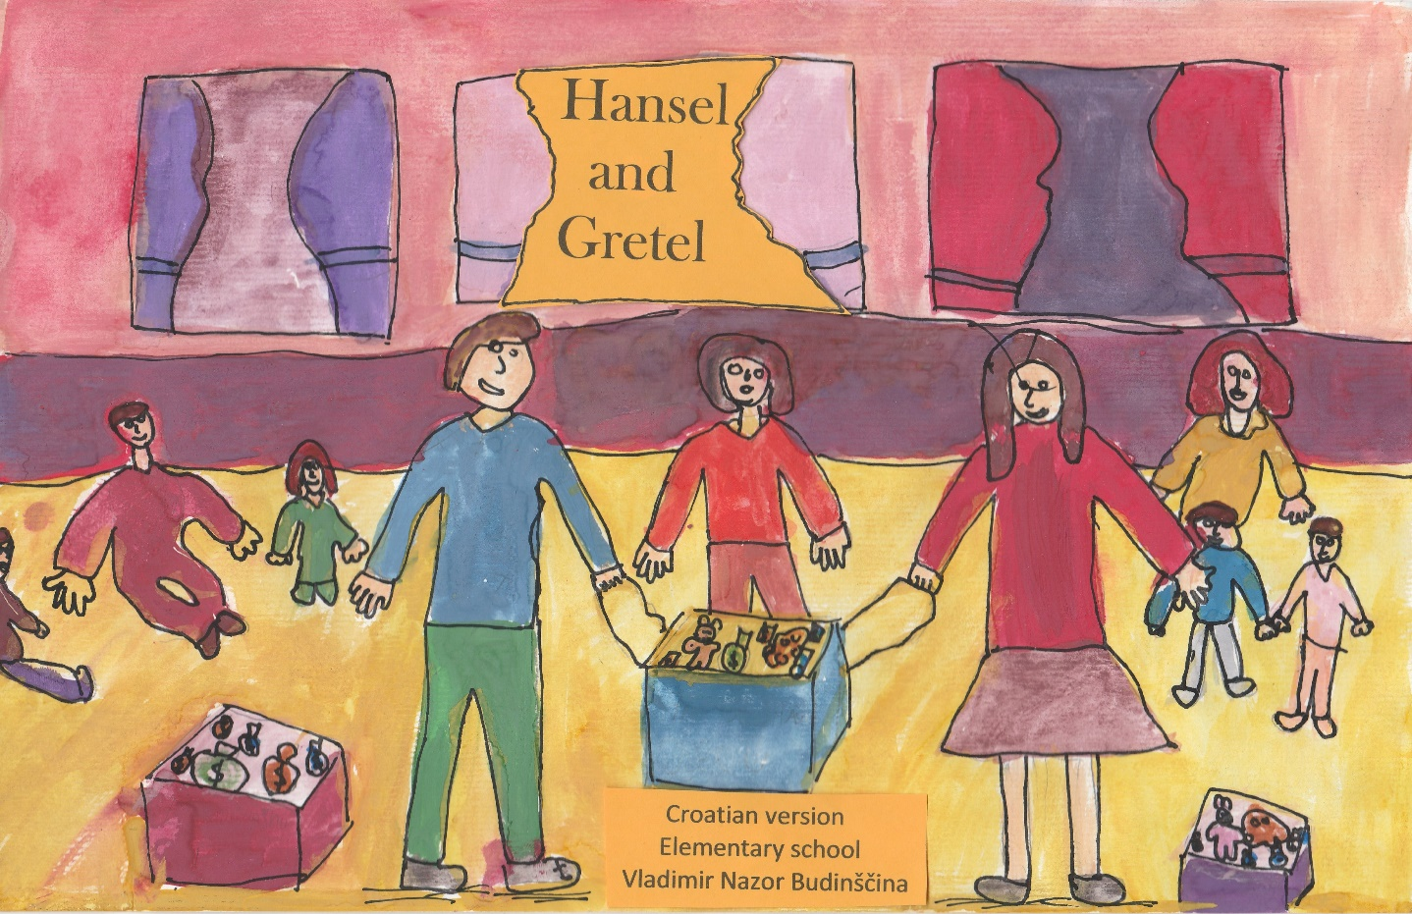
Once upon a time there lived a poor woood-cutter with his family. They lived in a small house near a forest. Their children’s names were Hansel and Gretel. The children loved their parents and the parents loved their son and their daughter.
But times were very hard. The parents had very little food and soon there was nothing left. The children were hungry. They were starving. So one day they dicided to look for some food. They went into the woords but they did not find anything. They went on further and finally came to a small cottage.
But the cottage was very strange. It was made of bread, cakes, cookies, biscuits, chocolate and sweets. The Windows were made of sugar and the rood was covered with bards of chocolate.
When the children saw that, they were very surprised. As they were hungry, they started to eat. Hansel took a piece of bread in one hand and a piece of cake in the other. Gretel took two bars of chocolate from the roof.
They were very happy with their discovery. But at the moment they heard a voice from the cottage. “Who is eating my house”? Hansel and Gretel did not pay too much attention to the voice.
They replied: “It’s just the wind”. But they heard the voice again. This time the voice was very loud and they had to answer.
They said: “We are poor children and we are starving. Can you help us and give us some food”?
They saw an old woman coming out of the cottage. She was wearing old clothes. She was weak and her legs were weak. She was carrying a walking stick. The children were frightened and about to run away. But the old lady invited them to come in. She told them that she would give them lots of food. She assured them that they would be fine. And so the children stayed.
The old woman offered them all kinds of food: milk, buns, fruitcake, apples, oranges, bananas, walnuts, fresh bread, roast meat, different salads and vegetables, and many other delicacies. The children were eating and eating until they were quite full. Then they drank some hot milk and they were ready to go to bed.
The old woman showed them two small beds with clean sheets and soft pillows and woolen blankets. So Hansel and Gretel got into the beds and were soon asleep. They even forgot to wash their hands and feet, Soon they were fast asleep.

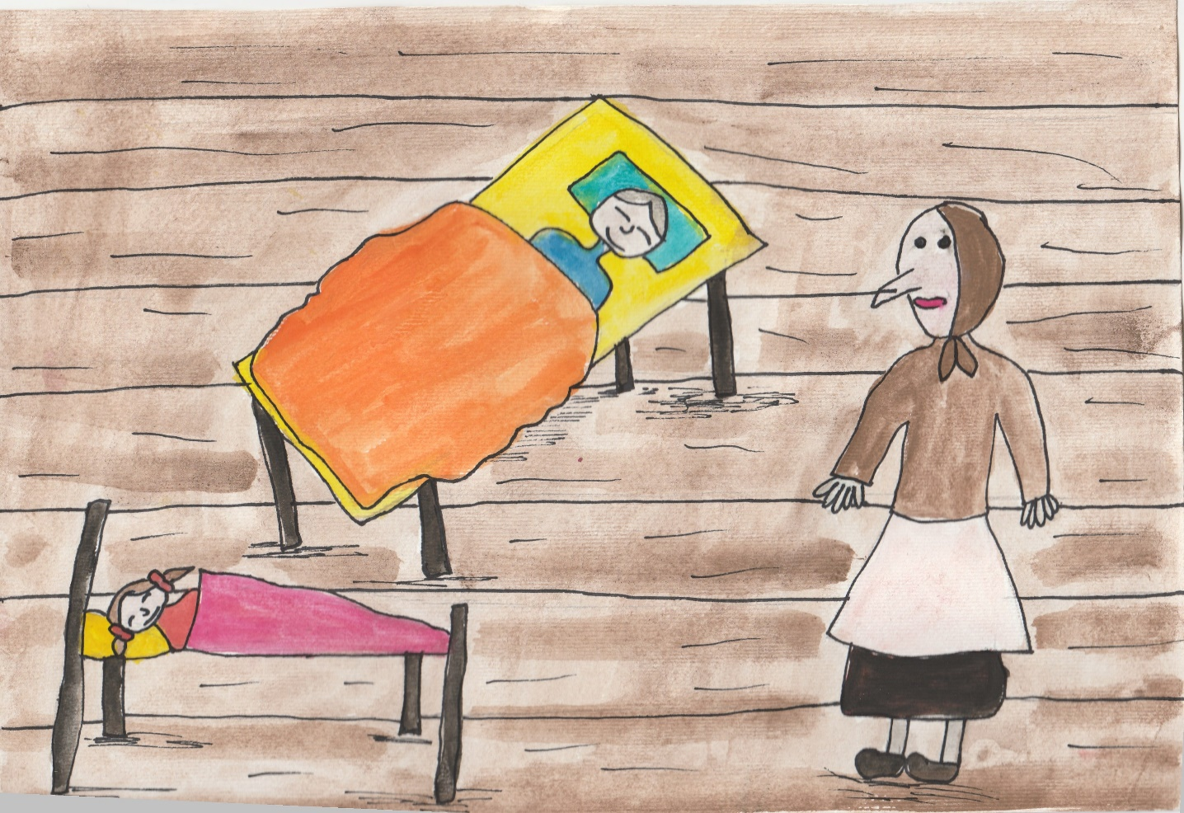
The old lady started laughing. The children did not know that the fruit and the vegetables the old lady gave them were full of sugar.

After some time, they woke up and soon realized that they were again very hungry. It was weird because they ate a lot just a few hours earlier.

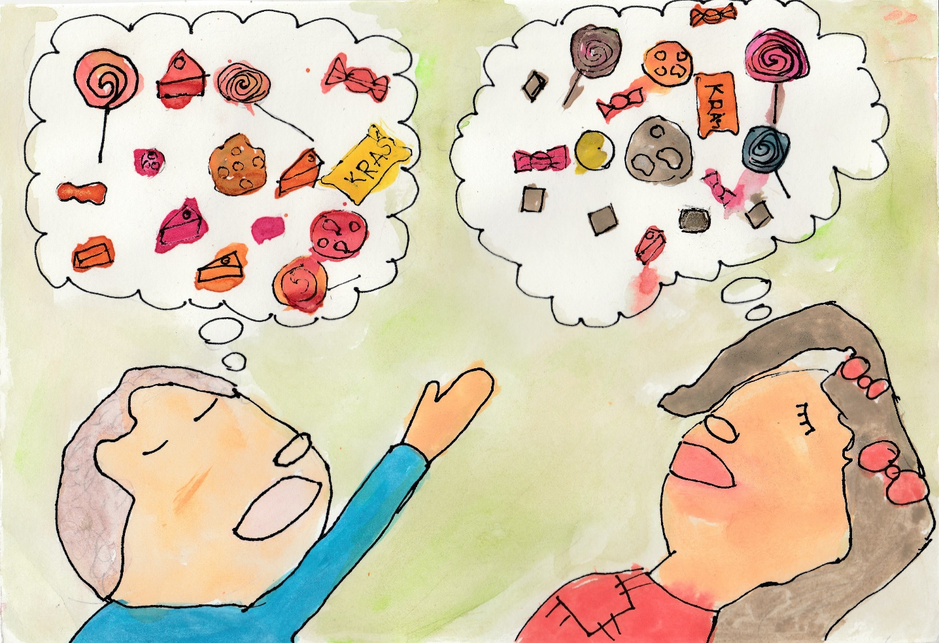

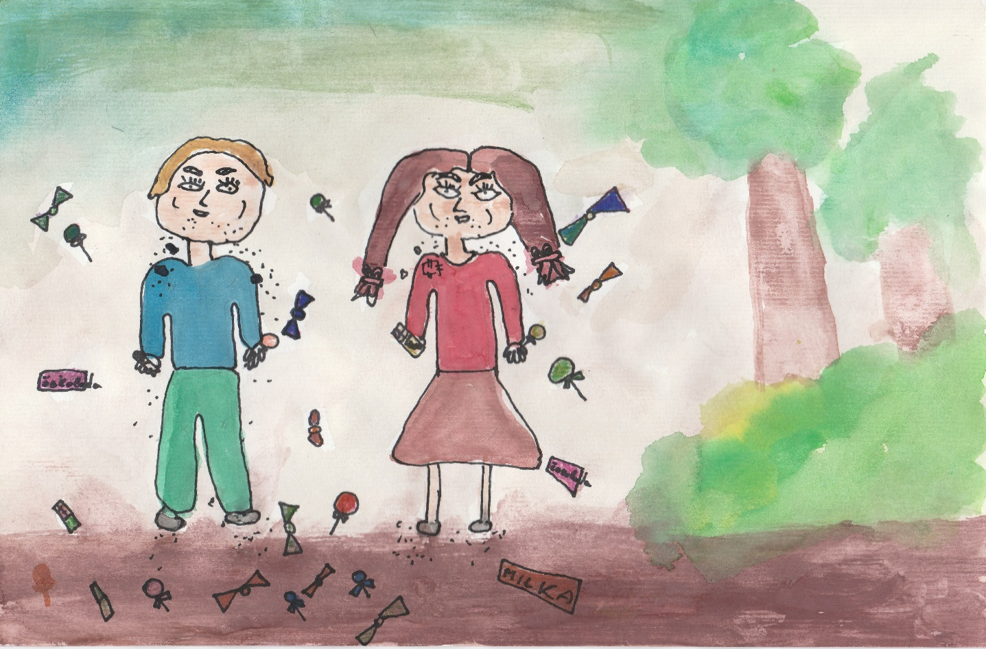
The old lady gave them a full bag of candies. Even though they knew candies are bad for their teeth, they could not resist.

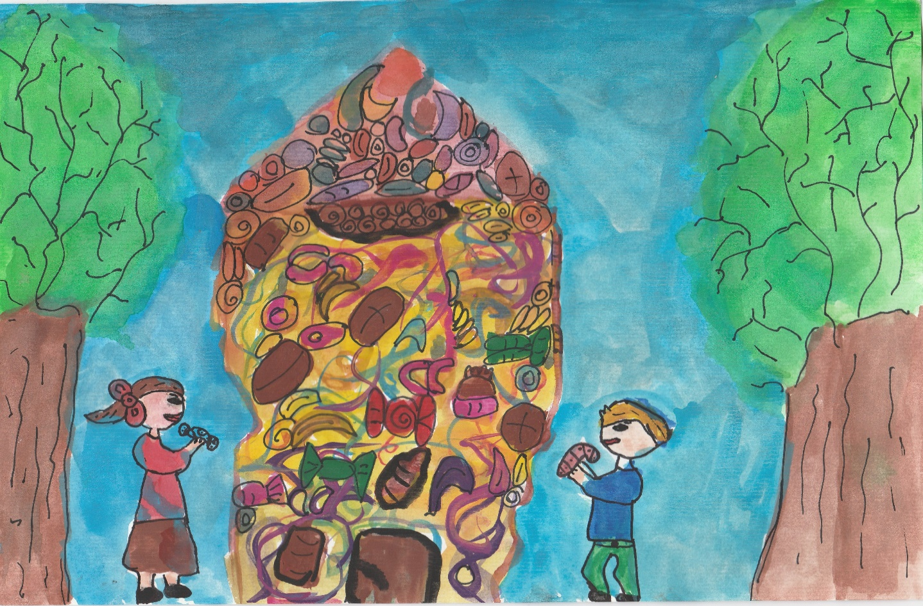
Every day they ate candies from the old lady’s cottage. After a month, they ate the whole cottage. After a long time, they were worried. They asked the old lady where they are going to live now, but she tried to calm them down by saying ‘Don’t worry, I’ve got a lot of candy houses throughout the forest’. Then they realized that something is wrong.

They decided to run away from the old lady the next day. However, during the night, almost all their teeth fell off.
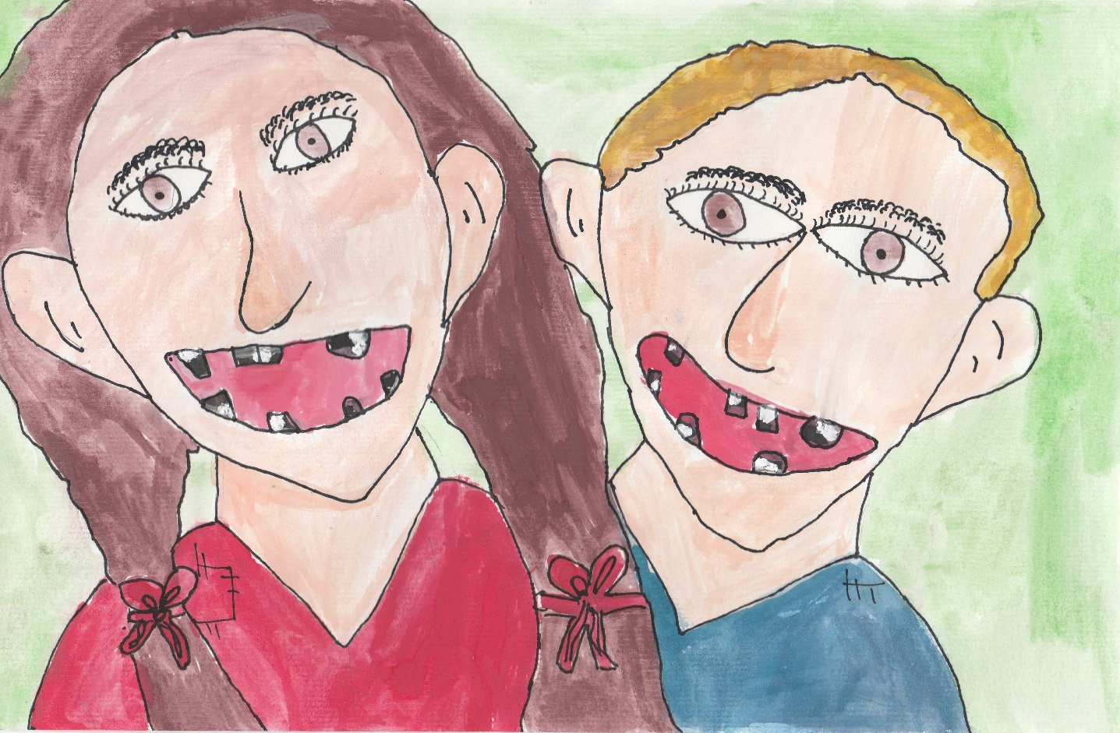

Early in the morning, something woke them up. The old lady was laughing in their face. She finally told them the truth. She admitted that she is a dentist who could not find enough patients to open the dental service. Then they realised why she had cottages all over the forest.
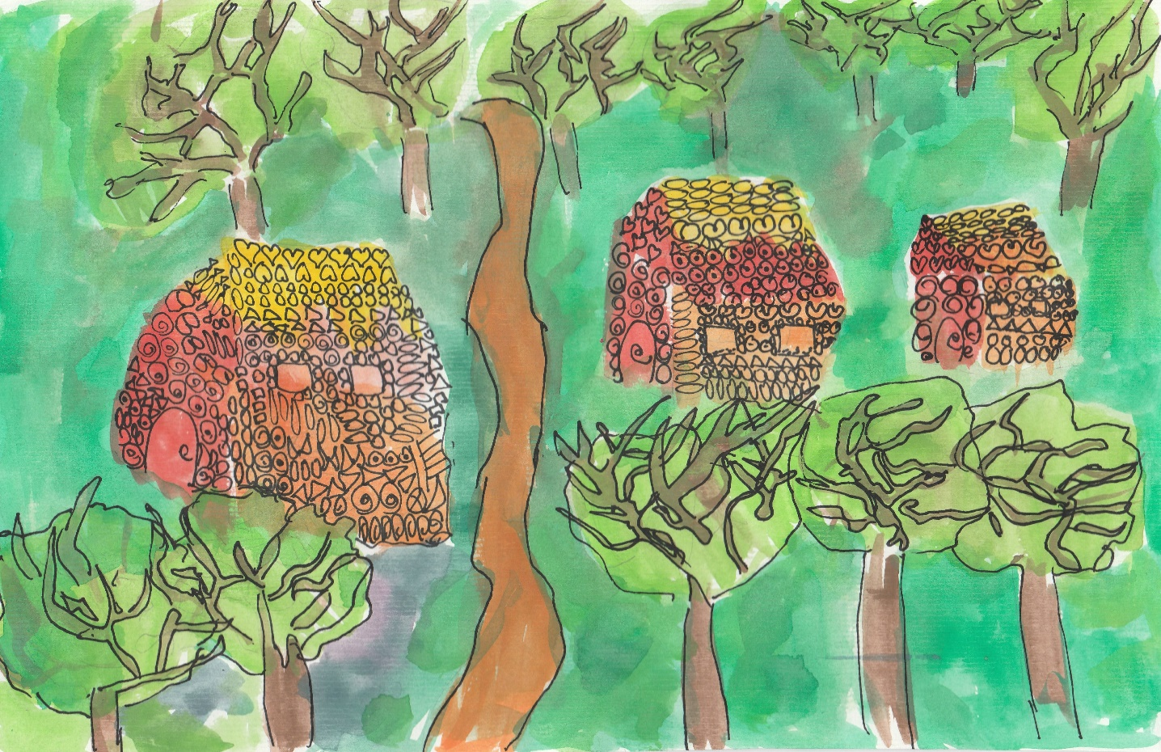

Her plan was to make kids eat her candies so they would ruin their teeth so that then they would need her to repair them. In that way, she would soon become rich.
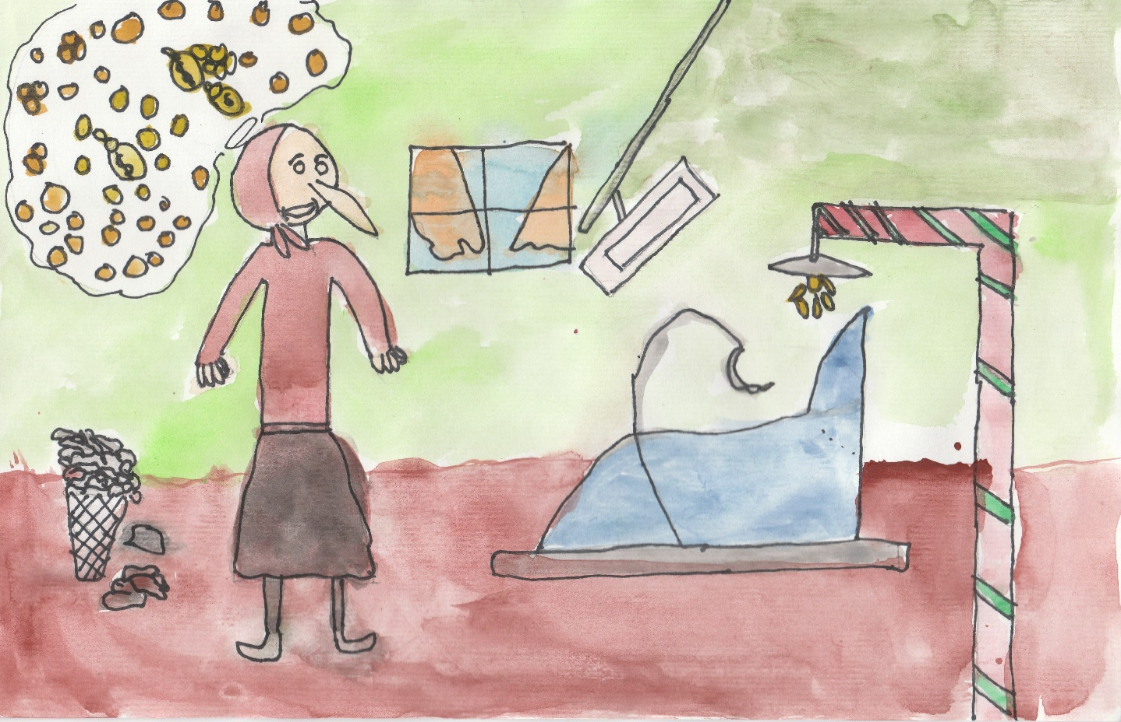

However, Hansel and Gretel’s parents did not have money so they could not understand why she gave them candies. She had a different plan on how to use their lack of teeth. She told them that, if they want her to fix their teeth, they should, from now on, instead of her, build candy cottages all over the forest because she is old now and she cannot do it on her own anymore.
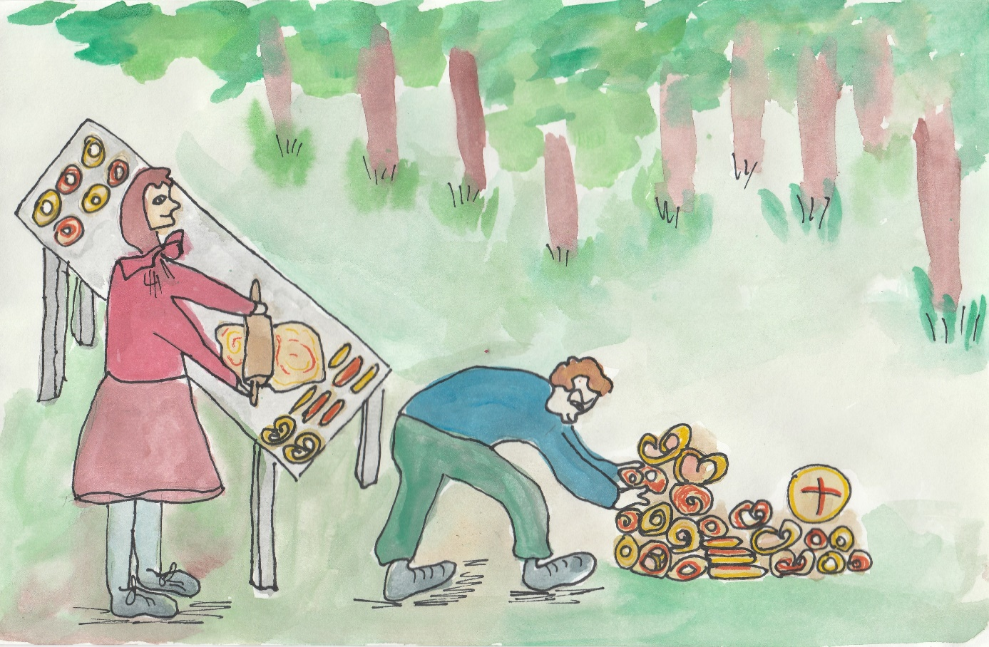

At first, they agreed because they wanted her to believe they are going to do it for her for the rest of their lives. But, after some time, they decided to run away.
Once, they got a job to build a cottage deep in the forest so the old lady decided not to go with them this time. They took a chance and ran away.
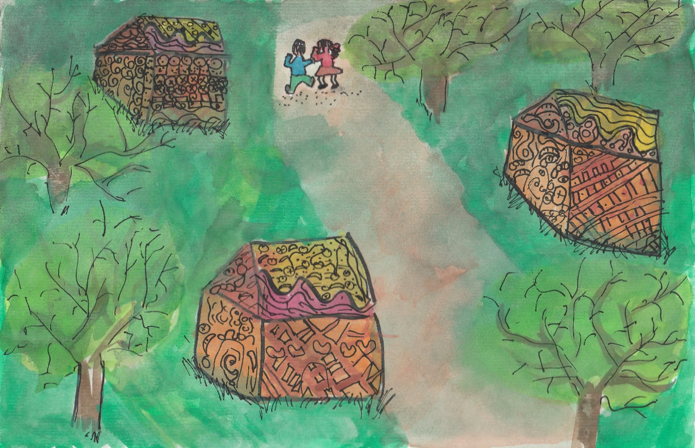

After wandering for some time, they found themselves on a lonely road. But, luckily, some man came by and helped them to return to the nearest village. He called the police and Hansel and Gretel told them what happened.
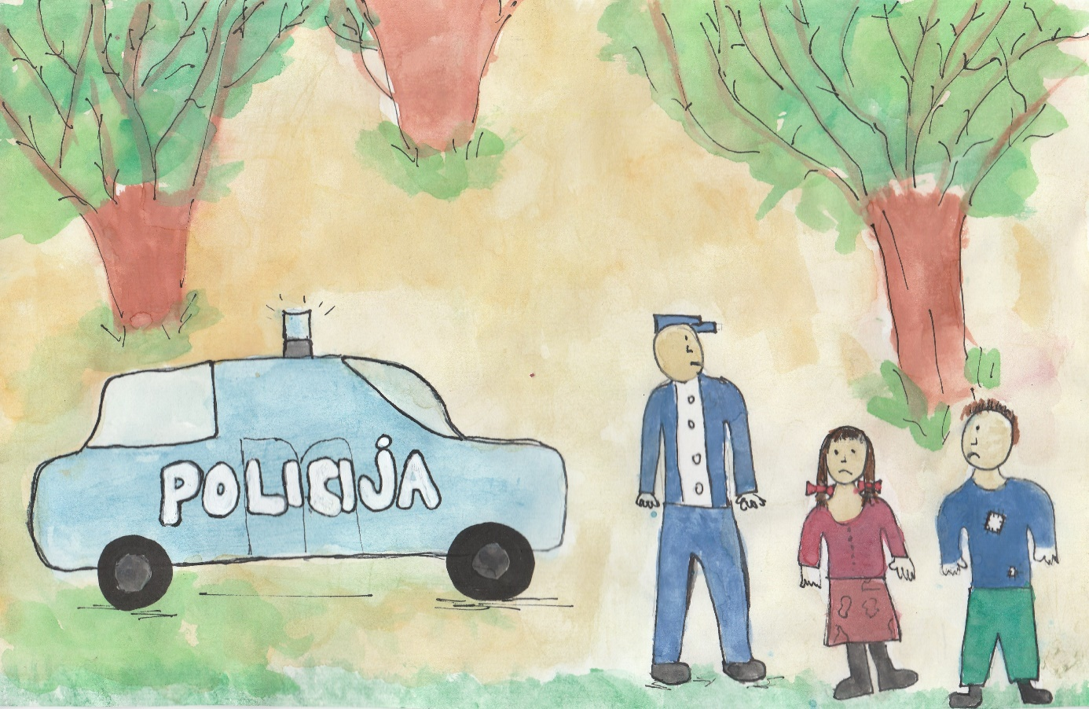

The police immediately went into the forest and soon they found the old lady and put her in jail.
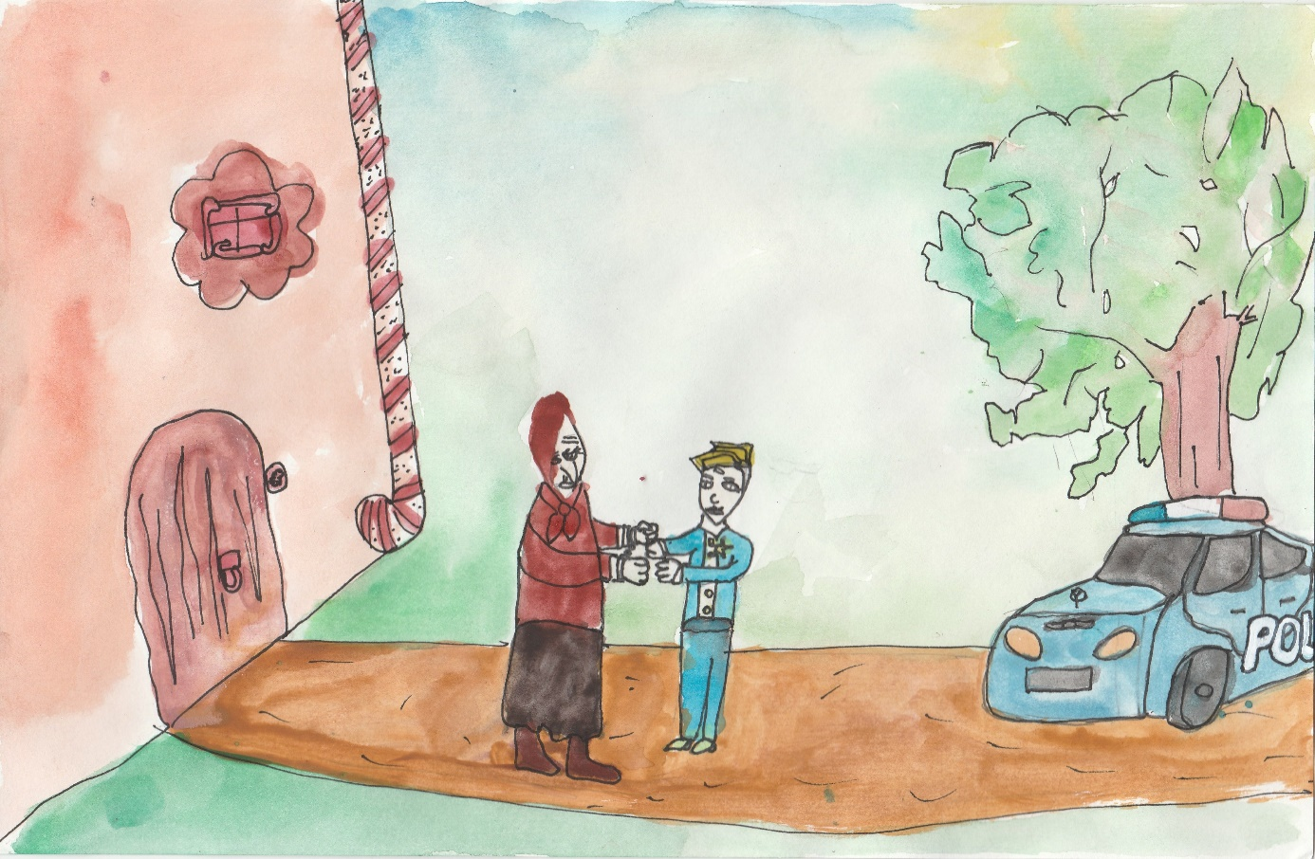

The police decided to give Hansel and Gretel all the money that the old lady got from the repairments, but they decided to share it with children whose teeth were destroyed by the wicked dentist as well as with the orphans from the nearest orphanage.
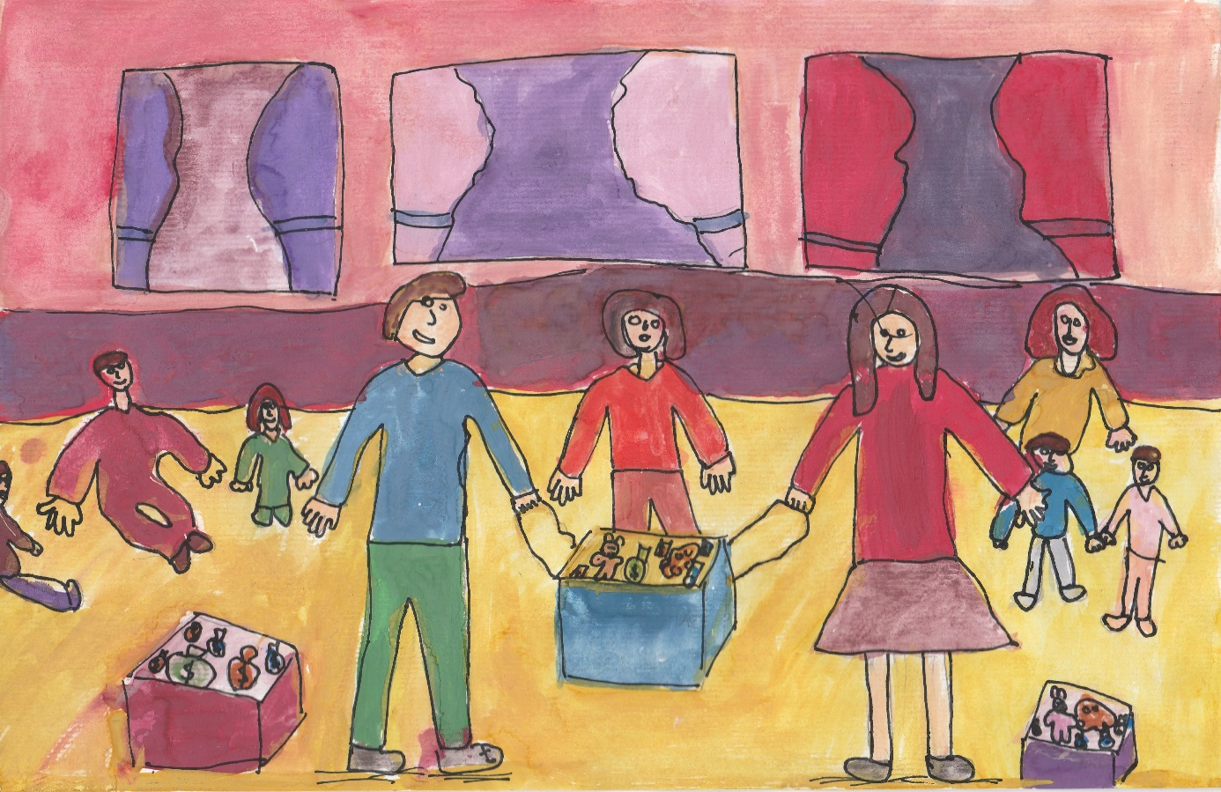

The old dentist’s punishment was to fix the teeth for everyone in jail, while Hansel and Gretel returned to their parents and lived happily ever after.
